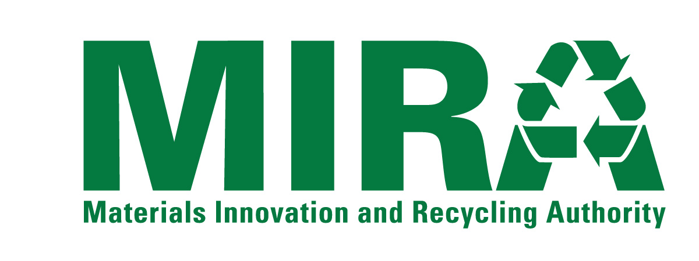
BUSINESS DISCLOSURE FORM

CONFLICTS OF INTEREST
In the space below, disclose any material assignments, relationships or other employment that the Proposer or any employee of the Proposer has with any member of MIRA’s Board of Directors,* any MIRA employee, law firms, governmental entity, or other person or entities that may create a conflict of interest or the appearance of a conflict of interest in providing the Services to MIRA.
*a list of Directors is available on the MIRA website at www.ctmira.org
[Attach Additional Pages If Necessary]

CONFLICT OF INTEREST MEASURES
In the space below, discuss any measures that the Proposer either has in place or would take to identify, disclose and resolve any possible conflicts of interest.
[Attach Additional Pages If Necessary]

BUSINESS WITH MAJOR MIRA CONTRACTORS
MIRA has made payments of over $100,000 a year to the organizations named on the MIRA Vendor List on Page 4 of this Form (the “Major MIRA Contractors”).
In the table below, disclose any services similar to the Services that are the subject of this solicitation that the Consultant has provided to any of the Major MIRA Contractors. If the Consultant has provided any such services, provide a summary description of the services provided.
Having provided the services similar to the Services that are the subject of this solicitation to one or more of the contractors listed below does not disqualify a Consultant from consideration under this solicitation. The nature and extent of the services provided, and appropriate conflict of interest rules will all be considered.
[Attach Additional Pages If Necessary]
Organization | Summary Description of Services Provided

MIRA Vendor List (FY 2014)
Payments Greater than $100,000
AON RISK SERVICES | HARTFORD, CITY OF
BOTTICELLO, INC. | KAINEN ESCALERA & MCHALE PC
CONNECTICARE, INC. | LINIUM STAFFING SVC
COPES RUBBISH REMOVAL | METROPOLITAN DISTRICT COMMISSION
COVANTA SOUTHEASTERN CT | METROPOLITAN LIFE INSURANCE COMPANY ASSET HOLDINGS II, LLC.
CONNECTICUT, STATE OF, DEEP | NAES CORPORATION
CONNECTICUT, STATE OF, DEPARTMENT OF REVENUE SERVICES | NEXTERA ENERGY POWER MARKETING LLC
COVANTA PROJECTS OF WALLINGFORD | NORTHEAST UTILITIES/CL&P
CWPM, LLC | PRESTON, TOWN OF
ET&L CORPORATION | SANTA BUCKLEY ENERGY, INC.
ENVIRONMENTAL CAPITAL LLC | SCS FIELD SERVICES
FCR, INC. | SOUTHEASTERN CONNECTICUT REGIONAL RESOURCES RECOVERY AUTHORITY
FIDELITY INVESTMENTS | TRC ENVIRONMENTAL CORP
FUSS AND ONEIL INC. | WHEELABRATOR BRIDGEPORT LP
GERSHMAN, BRICKNER & BRATTON, INC. | WHEELABRATOR TECHNOLOGIES INC
HALLORAN AND SAGE LLP

